**Truck Show expected to draw crowds of more than   
30,000 to BCEC**

The Brisbane Truck Show rolled into the [Brisbane Convention & Exhibition Centre (BCEC)](https://www.bcec.com.au/) this week – the largest indoor event to be held in Australia in the past 15 months.

As the biggest automotive exhibition in the Southern Hemisphere, the Truck Show is a prized event with the 2021 Show expected to generate $72 million in economic benefit for Brisbane, drawing more than 30,000 enthusiasts from all over Queensland and Australia wide.

The success of the event, organised by the [Heavy Vehicle Industry Australia (HVIA)](https://hvia.asn.au/), has meant that it now extends beyond the Centre with the South Bank Truck Festival taking over much of the parklands, in addition to other off-site locations.

The Centre’s Exhibition Halls have seen 1,100 truck movements through the doors, including big rigs, road trains and trucks of all sizes and shapes, demonstrating the very latest in transport technology and safety. Some 300 of the biggest names in international transport today are showcasing their products in a dazzling display worth millions of dollars.

The Brisbane Truck show is the largest exhibition held at BCEC both in size and scale, occupying the venue’s three levels. As part of the 2021 Show the Centre is hosting 19 associated events from seminars, breakfasts and dinners ranging from 10 to 370 attendees.

BCEC General Manager, Bob O’Keeffe said the return of the Brisbane Truck Show is a boost for the events industry but also a celebration and recognition of the important role truckies played keeping Australia going and supply chains open during COVID.

“It is another positive indication of a strong post COVID recovery for Brisbane with substantial impact on the economy from the direct expenditure of thousands of expected attendees, with the event delivering 70,000 room nights for the city’s hotels.”

Mr. O’Keeffe also noted the economic impact from the multiplier effect of the involvement of suppliers and others working on the Show including 3,000 contractors.

BCEC, an official #eatqld partner, promoting Queensland produce and supporting local growers, has sourced 650kg of Queensland beef, 1,050kg of Queensland chicken and 450kg of local salad vegetables for the event.

The Centre is expecting to serve 12,000 plated meals and 50,000 items of food over the duration of the event.

[**Watch Video**](https://youtu.be/aZOQamY58ck) **– Brisbane Truck Show Bump-in 2021,** see what it takes to put a show like this together.

[**Download images here**](https://ftp.bcec.com.au/public/folder/6-qbH3iIfUO2SJbmCKNZSw/Media%20Release%200521%20-%20Brisbane%20Truck%20Show)

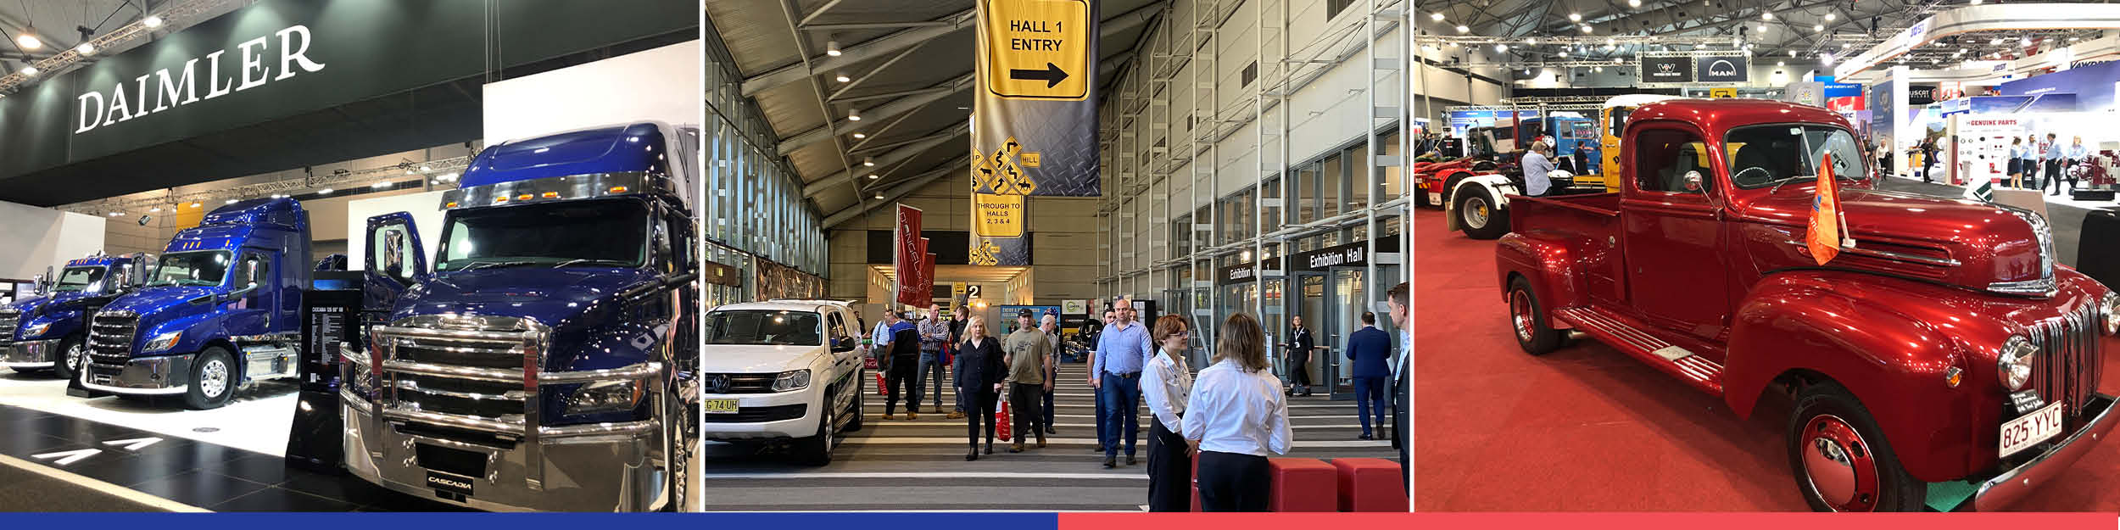

**Enquiries:** Gail Sawyer, Marketing and Communications Manager

**T**: +61 7 3308 3023 **M**: 0439 733 509 **E**: [gails@bcec.com.au](mailto:gails@bcec.com.au)

Date published: 14 May 2021

**About BCEC:** Brisbane Convention & Exhibition Centre is owned by South Bank Corporation and proudly managed by leading international venue management specialists ASM Global.

**About ASM Global:**

ASM Global is the world’s leading venue management and services company.  The company was formed by the merger of AEG Facilities and SMG, global leaders in venue and event strategy and management.  The company’s elite venue network spans five continents, with a portfolio of more than 300 of the world’s most prestigious arenas, stadiums, convention and exhibition centers, and performing arts venues. From Aberdeen to Anchorage, and Sydney to Stockholm, its venues connect people through the unique power of live experiences.

From its Asia Pacific headquarters in Brisbane, Australia, ASM Global operates a network of venues that includes convention & exhibition centres in Brisbane, Cairns, Darwin, Newcastle, Sydney, Christchurch (opening 2021), Kuala Lumpur and Shenzhen; Suncorp Stadium in Brisbane, Kai Tak Sports Park in Hong Kong (opening 2023) and interests in major stadia in Sydney, Parramatta and Perth; and entertainment arenas and performance theatres in Brisbane (4), Cairns, Darwin, Newcastle, Perth, Sydney (4), Bangkok (Em Live Theatre and Bangkok Arena both opening in 2023), Dubai, Hong Kong and Kuala Lumpur.

ASM Global’s diverse portfolio of clients benefit from the company’s depth of resources and unparalleled experience, expertise and creative problem-solving. Each day, the company’s 61,000 passionate employees around the world delivers locally tailored solutions and cutting-edge technologies to deliver maximum results for venue owners, and operations, and amazing experiences for guests. By consistently looking for new ways to envision, innovate and empower the spaces and places that bring people together, ASM Global elevates the human spirit while delivering the highest value for all stakeholders. For more information, please visit [www.asmglobal.com](http://www.asmglobal.com/)