**BCEC - runner-up in World’s Best**

**Convention Centre Award**

[Brisbane Convention & Exhibition Centre](https://www.bcec.com.au/) (BCEC), managed by [ASM Global](https://asmglobal.com/) and named World’s Best Convention Centre by the [International Association of Congress Centres](https://aipc.org/) (AIPC), for 2016 – 2018, continues to stay at the top of world rankings, voted runner-up in the latest survey.

The coveted internationally recognised AIPC APEX Award, based solely on client evaluations, recognises achievement in high quality customer service and venue management.

The independently assessed survey found that eight in ten clients rated their overall experience with Brisbane Convention & Exhibition Centre as ‘excellent’, with the Centre performing above the industry average for all key touchpoints.

BCEC General Manager Bob O’Keeffe AM described the Award as an international benchmark for industry excellence and something the Centre strived for each and every day.

“We would like to acknowledge our many loyal and long-term clients, and those who have steadfastly supported us through these past months during our recovery phase.

“This award is also recognition of the Centre’s dedicated and passionate team, and a true reflection of the Centre’s strong customer experience focus.”

Queensland Premier Annastacia Palaszczuk said Brisbane Convention & Exhibition Centre would play an important role in the city’s economic recovery.

“Queensland’s reputation as a world class destination for major events is one reason our bid for the 2032 Olympic Games was so successful,” the Premier said.

“The quality of our venues like Brisbane Convention & Exhibition Centre is a strong selling point for Queensland.

“And thanks to the way Queenslanders have responded to the pandemic, we’re seeing our economy recover more quickly than other states.

“Brisbane Convention & Exhibition Centre has done a great job hosting COVID safe events throughout the pandemic. This recognition is well deserved.

“We support events because we know they’re vital when it comes to supporting local jobs and businesses. BCEC will continue to play an important role in our COVID-19 Economic Recovery Plan.”

BCEC was the first convention centre in Australia to reopen following the COVID–19 pandemic, and has since hosted 280,000 guests at 480 events. That strong recovery was supported by strict health and safety guidelines integrated with VenueShield, an environmental hygiene protocol developed by BCEC’s parent group, ASM Global and rolled out at 325 venues worldwide.

Having led the recovery of convention centre business, both nationally and globally, BCEC is now actively supporting the COVID-19 vaccine rollout by Queensland Health, acting as a mass vaccination hub.

One of the Centre’s 5,000sqm Exhibition Halls is now the state’s largest community vaccination location, set up to deliver 3,000 vaccinations daily, seven days week.

Bob O’Keeffe said the Centre welcomed the opportunity to assist the vaccine rollout for Brisbane. “This is Queensland’s road to recovery from COVID-19 and we will continue to support the Queensland Government in any way we can”.

He said despite the Centre tracking well, recent lockdowns had again disrupted business, but believes expediating the vaccine rollout is key to the industry’s return to business.

**[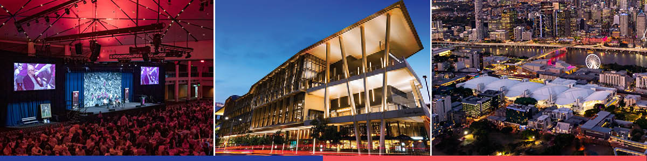](https://ftp.bcec.com.au/public/folder/tFc8R1684EainMou-PfE4Q/tFc8R1684EainMou-PfE4Q)**

[**Download images**](https://ftp.bcec.com.au/public/folder/tFc8R1684EainMou-PfE4Q/tFc8R1684EainMou-PfE4Q)

**Enquiries:** Gail Sawyer, Marketing and Communications Manager

**T**: +61 7 3308 3023 **M**: 0439 733 509 **E**: [gails@bcec.com.au](mailto:gails@bcec.com.au)

Date published: 11August 2021

**About BCEC:** Brisbane Convention & Exhibition Centre is owned by South Bank Corporation and proudly managed by leading international venue management specialists ASM Global.

**About ASM Global**

**ASM Global is the world’s leading producer of entertainment experiences. It is the global leader in venue and event strategy and management – delivering locally tailored solutions and cutting-edge technologies to achieve maximum results for venue owners. The company’s elite venue network spans five continents, with a portfolio of more than 325 of the world’s most prestigious arenas, stadiums, convention, and exhibition centers, and performing arts venues.**

**ASM Global (Asia Pacific)**

**From its Asia Pacific headquarters in Brisbane, Australia, ASM Global operates a network of venues that includes convention & exhibition centres in Brisbane, Cairns, Darwin, Newcastle, Sydney, Bahrain (opening in 2022), Christchurch (opening 2021) and Jeddah (under development), Kuala Lumpur and Shenzhen; Suncorp Stadium in Brisbane, Kai Tak Sports Park in Hong Kong (under construction) and interests in major stadia in Sydney, Parramatta and Perth; and entertainment arenas and performance theatres in Brisbane (4), Cairns, Darwin, Newcastle, Perth, Sydney (4), Bangkok (Em Live Theatre and Bangkok Arena both opening in 2023), Dubai, Hong Kong, Kuala Lumpur and Jeddah (under development).**

**ASM Global’s diverse portfolio of clients benefit from the company’s depth of resources and unparalleled experience, expertise and creative problem-solving. Each day, the company’s tens of thousands of passionate employees around the world deliver locally tailored solutions and cutting-edge technologies to deliver maximum results for venue owners and amazing experiences for guests. By consistently looking for new ways to envision, innovate and empower the spaces and places that bring people together, ASM Global elevates the human spirit while delivering the highest value for all stakeholders. For more information, please visit** www.asmglobal.com**.**