# **World leading computer modelling experts to meet in Brisbane**

Some of the world’s top brains in engineering, science and mathematics are set to put Brisbane on the agenda for the Asia Pacific Congress on Computational Mechanics (APCOM) in 2025.

Brisbane’s world leading research and expertise in the field of computer sciences and computational mechanics will take centre stage at the Congress to be held at the Brisbane Convention & Exhibition Centre (BCEC).

The team at BCEC collaborated with the Queensland University of Technology (QUT), supported by Tourism & Events Queensland and Brisbane Economic Development Agency (Brisbane EDA) to secure the event for Brisbane.

QUT is a global leader in Computational Mechanics research, which is a core interdisciplinary science that helps us understand societal, economic and environmental challenges.

Australia possesses a vibrant research environment and culture within the field of computational mechanics, providing a strong scientific basis for the Congress.

Congress Chair, Professor YuanTong Gu, Head of School, Mechanical, Medical & Process Engineering at QUT, and internationally renowned in the field of Computational Mechanics, led a persuasive bid together with the BCEC team to win the Congress for Brisbane against strong competition from Hong Kong and South Korea.

Professor Gu said Brisbane’s worldwide reputation as a leader in science and technology was a key factor in the city’s selection to host the Congress. “The strong support of the Australian Association for Computational Mechanics as well as from the Queensland Government, BCEC, Brisbane EDA, and QUT was critical to the success of the bid,” he said.

BCEC and Brisbane have secured 17 international meetings in the past 12 months across health, science, technology, agriculture, mining and social welfare, which are expected to deliver 20,000 delegates to Brisbane with an estimated $52.5 million in direct expenditure for the Queensland economy.

The team at BCEC recently confirmed two large international bid wins expected to attract 8,000 and 2,000 delegates respectively, offering some much-needed optimism for the industry.

BCEC General Manager, Bob O’Keeffe said the recent bid win activity was encouraging and an expression of guarded confidence about Australia from the international market.

‘‘On the home front, we are also witnessing an upswing in general enquiries and bookings. We are cautiously optimistic that the industry is in the early stages of a post-COVID recovery and BCEC is one of the best placed venues in the country to take advantage of the improving business environment,” he said.

Lord Mayor Adrian Schrinner said it’s great to see so many organisations choosing Brisbane to host their conferences and business events.

“Along with demonstrating Brisbane as a world-class events host with globally-renowned event facilities, these conferences will attract thousands of high-value business travellers to fill our venues and hotels, dine at our restaurants and enjoy the many attractions on offer in Brisbane,” Cr Schrinner said.

Asia Pacific Congress on Computational Mechanics is supported by the Queensland Government through Tourism and Events Queensland and features on the It’s Live in Queensland events calendar.

[**Download images here**](https://ftp.bcec.com.au/public/folder/tsDInGbjgkeeFU6WMwgrKA/Media%20release%200521)

**[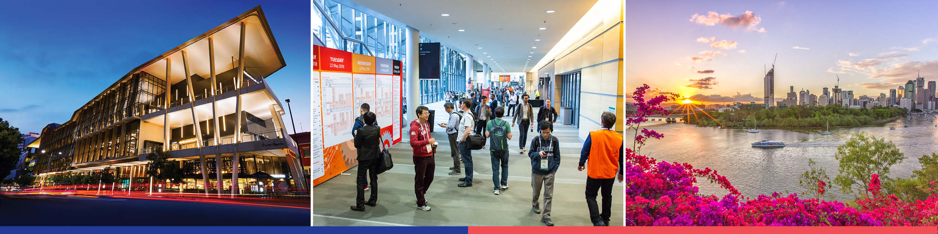](https://ftp.bcec.com.au/public/folder/tsDInGbjgkeeFU6WMwgrKA/Media%20release%200521)**

**Enquiries:** Gail Sawyer, Marketing and Communications Manager

**T**: +61 7 3308 3023 **M**: 0439 733 509 **E**: [gails@bcec.com.au](mailto:gails@bcec.com.au)

Date published: 5 May 2021

**About BCEC:** Brisbane Convention & Exhibition Centre is owned by South Bank Corporation and proudly managed by leading international venue management specialists ASM Global.

**About ASM Global:**

ASM Global is the world’s leading venue management and services company.  The company was formed by the merger of AEG Facilities and SMG, global leaders in venue and event strategy and management.  The company’s elite venue network spans five continents, with a portfolio of more than 300 of the world’s most prestigious arenas, stadiums, convention and exhibition centers, and performing arts venues. From Aberdeen to Anchorage, and Sydney to Stockholm, its venues connect people through the unique power of live experiences.

From its Asia Pacific headquarters in Brisbane, Australia, ASM Global operates a network of venues that includes convention & exhibition centres in Brisbane, Cairns, Darwin, Newcastle, Sydney, Christchurch (opening 2021), Kuala Lumpur and Shenzhen; Suncorp Stadium in Brisbane, Kai Tak Sports Park in Hong Kong (opening 2023) and interests in major stadia in Sydney, Parramatta and Perth; and entertainment arenas and performance theatres in Brisbane (4), Cairns, Darwin, Newcastle, Perth, Sydney (4), Bangkok (Em Live Theatre and Bangkok Arena both opening in 2023), Dubai, Hong Kong and Kuala Lumpur.

ASM Global’s diverse portfolio of clients benefit from the company’s depth of resources and unparalleled experience, expertise and creative problem-solving. Each day, the company’s 61,000 passionate employees around the world delivers locally tailored solutions and cutting-edge technologies to deliver maximum results for venue owners, and operations, and amazing experiences for guests. By consistently looking for new ways to envision, innovate and empower the spaces and places that bring people together, ASM Global elevates the human spirit while delivering the highest value for all stakeholders. For more information, please visit [www.asmglobal.com](http://www.asmglobal.com/)